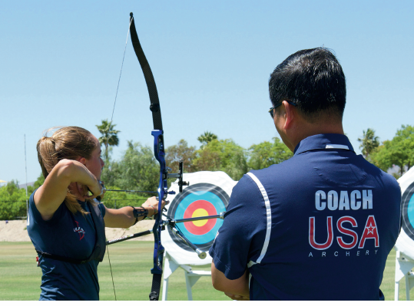  - BLACKSTONE VALLEY ARCHERY CLUB  Junior Olympic Archery Development (JOAD)  Junior Olympic Archery Development (JOAD) is a program of USA Archery  for youth ages 8-20 years conducted in a Club setting. Participants in  the JOAD program can enjoy the sport recreationally or progress to the  excitement of competition. The JOAD program offers barebow, basic  compound, recurve, and compound archers the opportunity to learn range  safety and proper shooting technique in an environment that also fosters  increased self-confidence and team-building skills. The JOAD program  also provides an achievement award program to reward archers for scoring achievements.  The Blackstone Valley Archery Club (BVA) is a Massachusetts based, nonprofit corporation, staffed by skilled volunteers who are dedicated to providing a safe atmosphere for all club members to participate in the development and exploration of archery. Lessons will combine classroom and range time, in order to provide comprehensive training in all facets of the sport, from range safety awareness to actual application of target practice, with fun and exciting activities for all to participate in.  The Club will meet on Sunday afternoons, @ 1:30 PM and will run approximately 60 minutes. A valid membership with USA Archery is required. BVA club dues are $160 per member ($20 per week) for the 8 week course | Hosted by the Bellingham Sportsman’s Club, located at 360 Lake St. Bellingham MA, 02019  ____  Ages 10-18 , beginners and all levels of experience welcome!  ____  Safety Equipment, Recurve and Compound bows provided.  ____  JOAD lessons for 8 weeks, beginning 9/15/2019  Class size limited  ____  Sign up’s held at Bellingham Sportsman’s Club, Monday August 26th &Tuesday August 27th from 6PM to 8PM  Blackstone Valley Archery INC.  109 Blackstone St.  Blackstone MA, 01504  508-328-3623  Contact:David Azevedo  Level 2 Instructor &  Club President

