Please Join Us! Saturday Night from 7:30-9:30pm
at Horizons Edge Sports Complex
as we help Bob Ryder celebrate 40 years of Hosting the US Indoor Archery Championship
Live Music by
Everyday People
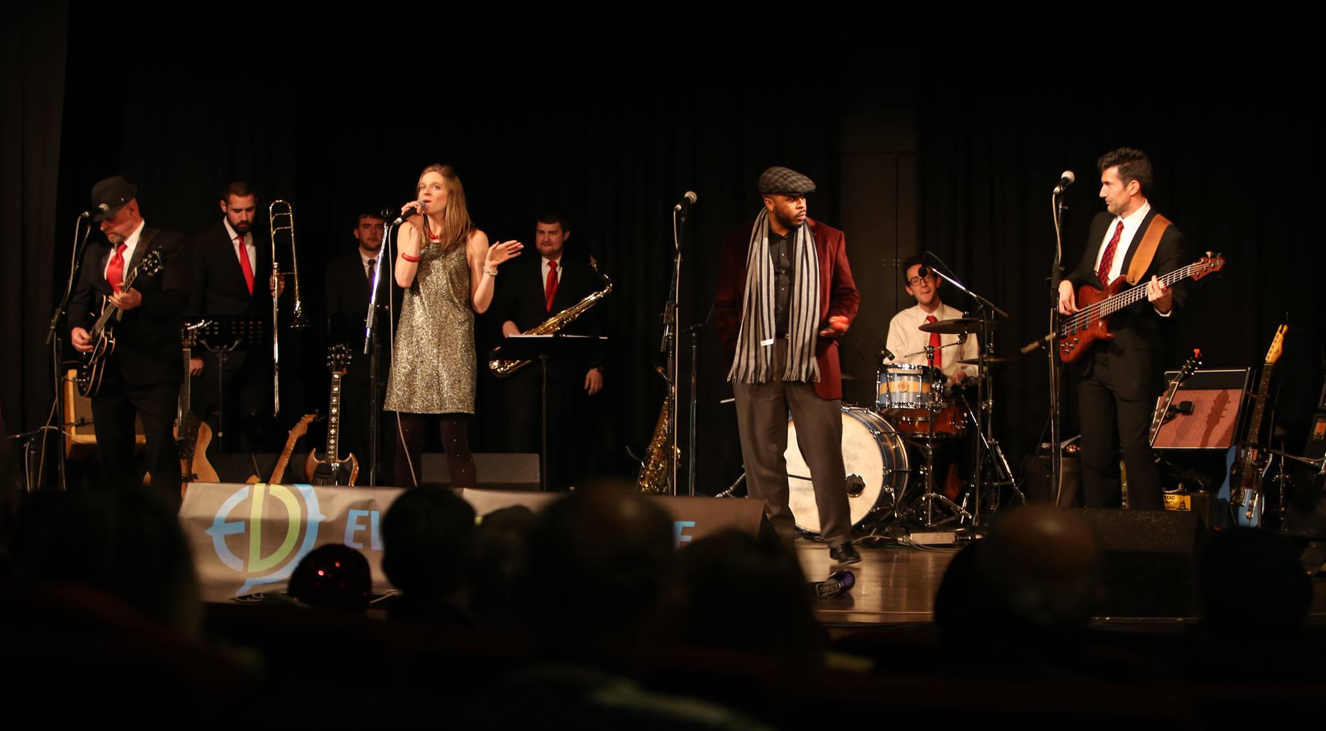
Everyday People is an 8-piece horn driven band who will unleash Funk, Soul and R&B that makes you want to get on the dance floor. Join us for a dose of Uptown Funk!

