2023 US Indoor Seminars

Seminars – Friday, February 17, 2023

6-7pm… Archery Tournaments… w/Bob Ryder

“Tips & Tricks of Running Successful Tournaments”

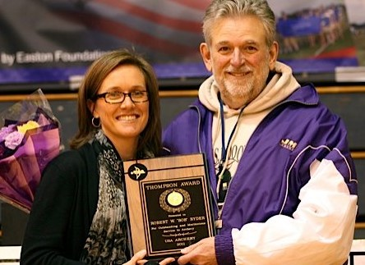
(JMU Archery Team - Coach)
Bob is a USA Archery Level 4 NTS Coach & Level 3 NTS Coach Trainer. He is a 2011 Recipient of the Maurice Thompson Medal of Honor, a 4-time National Collegiate Archery Coach of the Year, a past US Intercollegiate All-American and National Champion, past member of the US Archery Team, National Judge, Tournament Director for over 60 National Archery Championships, including National Indoor, Outdoor Target and Field Championships as well as a US Olympic Festival and World Team Trials.

Who is the Target Audience? – Anyone who is crazy enough to want to run an Archery Tournament or help someone who runs archery tournaments. This includes archers, parents, fellow coaches, fellow tournament directors and volunteers.

What will be covered? – I will have a handout or two that should be helpful to anyone running tournaments, especially for USA Archery. But I want to make this as personal and helpful as possible, so everyone, please bring me your hardest questions and your biggest concerns and we’ll see if we can’t provide a reasonable solution.

2023 US Indoor Seminars

Seminars – Saturday, February 18, 2023

9-10am… Tournament Prep… w/Bob Ryder

“How to Prepare for Your Next Major Competition”

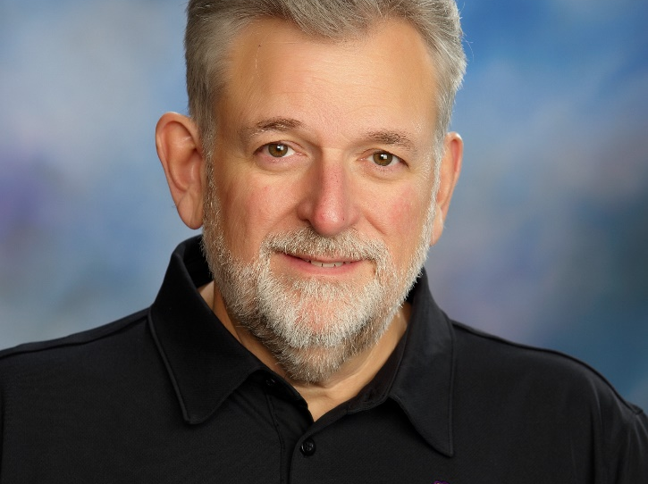
(JMU Archery Team - Coach)
Bob is a USA Archery Level 4 NTS Coach & Level 3 NTS Coach Trainer. During his tenure as Head Coach the James Madison University Archery Team produced 42 All-Americans, 16 National Champions, 23 National Team Titles and 14 World Champions. In his 65 years of experience in the world of archery competition as competitor and a coach he has seen everything that can go wrong and will be sharing tips and advice on how to make sure that you and your archers are prepared for the challenges they may face.

Who is the Target Audience? – Anyone who wants to take a serious look at what’s actually involved in preparing for an archery tournament. This includes archers, parents, and fellow coaches.

What will be covered? – I will have a handout that lays out clearly what all is involved in tournament prep for the serious archer. Some items will be a stretch for newer archers but will provide a guideline for all to follow for even major events. There should be a lot of discussion about preparation for a variety of experience levels and different degrees of expertise.

2023 US Indoor Seminars

Seminars – Saturday, February 18, 2023

10-11am… JOAD Programs… w/Cindy Bevilacqua

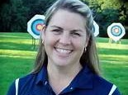
(Middletown Archery Club)
Cindy is a USA Archery Level 4 NTS Coach who runs a successful Archery Club and JOAD Program in Media, PA. She was the USA Olympic Archery Team Leader for London 2012. She is also, Past USAT Team Member, Past Collegiate All-American, National Champion and Athlete of the Year for JMU and has been inducted into the JMU Athletic Hall of Fame. She has been a JOAD Coach since 1984 and was named Coach of the Year in 1996. Cindy has the experience and expertise to help you with the many obstacles you face as a JOAD Club leader. She’s got the answers.

Who is the Target Audience? – Anyone who is interested in starting a new JOAD Program or simply looking for ideas to improve an existing program. This includes parents, fellow coaches and volunteers.

What will be covered? – Cindy is qualified to provide guidance in starting and running a JOAD program, the importance of having certified instructors & coaches leading the program, building a successful local club and developing a quality traveling team. Bring your questions and concerns and she will give you the direction you’ve been looking for.

2023 US Indoor Seminars

Seminars – Saturday, February 18, 2023

1-2pm… Collegiate Archery… w/Andy Puckett

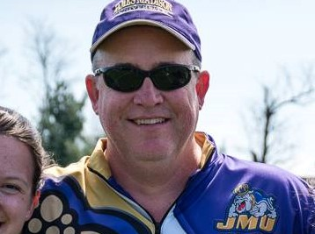
(JMU Archery – Head Coach)
Andy is a USA Archery Level 3 NTS Coach and Head Coach of the James Madison University Archery Team. He is the 2017 Coach of the Year. He will be able to answer questions of transitioning from JOAD to the College Division. He will also be ready to discuss the current structure of the College Division Champion and the changes that may be needed and how to implement them to strengthen the College Division for the future.

Who is the Target Audience? – Anyone who is interested in the process of transitioning from JOAD to Collegiate Archery, as well as any current or hopeful collegiate coach, assistant, or volunteer. This includes archers, parents, fellow coaches, and volunteers.

What will be covered? – As Head Coach of the JMU Archery Team w/20+ years’ experience along with being the College Program’s Director of the East Region, Andy is a wonderful resource for those who hope to learn what experiences are available in the College Program and is anxious to discuss the direction of the program with current coaches. Should be a very interesting program.

2023 US Indoor Seminars

Seminars – Saturday, February 18, 2023

2-3pm… Tuning for Recurve… w/Bryan Brady
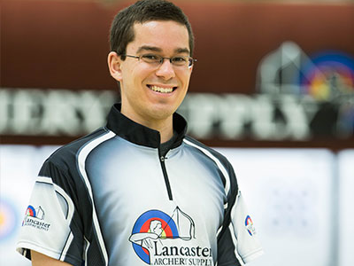
(Lancaster Archery Academy-Team Lead)
Bryan is a USA Archery Level 4 NTS Coach and Lancaster Academy Team Lead. Bryan started shooting Olympic Recurve at JMU where he gained his first Coaching Certifications and went on to serve as an Assistant Coach after graduation. He joined the Lancaster Archery Academy in 2015 and continues to pursue his coaching and competitive careers as he coaches archers at the Academy and competes actively on the USAT Circuit.

Who is the Target Audience? – Anyone who wants to learn more about getting the most performance and forgiveness out of their recurve bow. This includes archers, parents, and fellow coaches.

What will be covered? – Bryan will start with the basics and take you to the more advanced techniques. Some steps will be more than newer archers need to be concerned with but will provide a guideline for all to follow as their skill level and expertise evolve.

2023 US Indoor Seminars

Seminars – Saturday, February 18, 2023

5-6pm… Tuning for Barebow… w/Frank McDonough

(The Barebow Project & GHA)
Frank is a USA Archery Level 4 NTS Coach, Scholastic 3D Archery Advanced Coach, and a National Archery In the Schools Coach. While Frank is mostly known as a barebow archery coach, since founding The Barebow Project and coaching shooters worldwide through that platform. But Frank has developed multiple youth and adult national champions along with national and world record holders in each discipline.

Who is the Target Audience? – Anyone who wants to learn more about getting the most performance and forgiveness out of their barebow rig. This includes archers, parents, and fellow coaches.

What will be covered? – Frank will start with the basics and take you to the more advanced techniques. Some steps will be more than newer archers need to be concerned with but will provide a guideline for all to follow as their skill level and expertise evolve.

2023 US Indoor Seminars

Seminars – Saturday, February 18, 2023

6-7pm… Tuning for Compound… w/Darryll Diehl

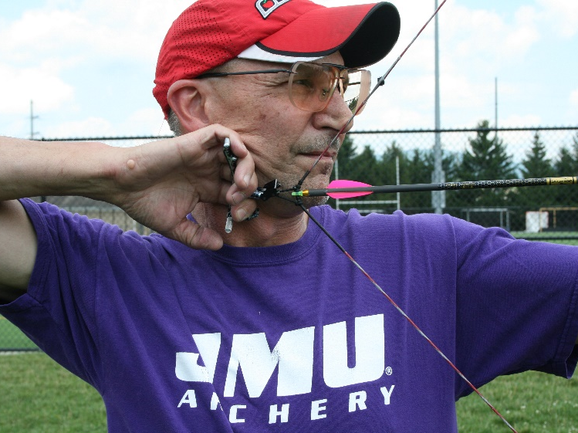
(JMU Archery Team – Coach)
Darryll is a USA Archery Level 3 NTS Coach and Assistant Coach of the James Madison University Archery Team. He is a two-time NFAA National Field Champion who has competed and continues to compete successfully at the Vegas Shoot and the Atlantic City Archery Classic in addition to many other national events. His experience and expertise are key to the development and future success of the JMU Archery Team.

Who is the Target Audience? – Anyone who wants to learn more about getting the most performance and forgiveness out of their recurve bow. This includes archers, parents, and fellow coaches.

What will be covered? – Bryan will start with the basics and take you to the more advanced techniques. Some steps will be more than newer archers need to be concerned with but will provide a guideline for all to follow as their skill level and expertise evolve.

2023 US Indoor Seminars

Seminars – Sunday, February 19, 2023

9-10am… The Mental Game… w/Bob Ryder

“Developing Your Own Mental Game”

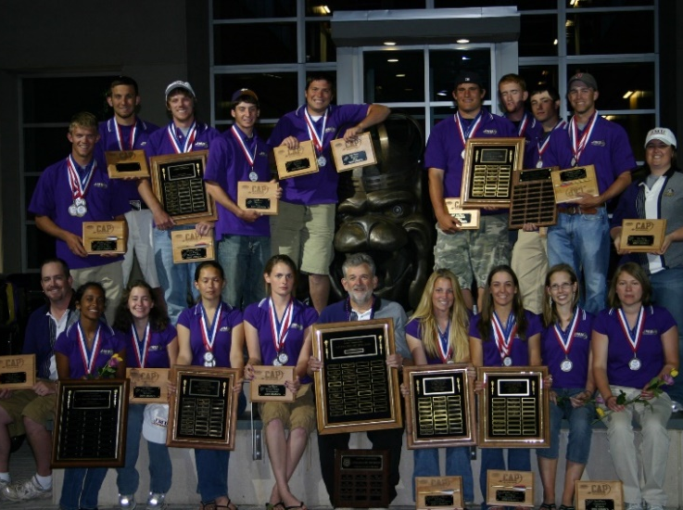
(JMU Archery - Coach)
Bob has written numerous articles on the Mental Game and his book, “Bob Ryder on Coaching Collegiate Archery” was published including 13 Chapters on the Mental Game. Bob is a USA Archery Level 4 NTS Coach & Level 3 NTS Coach Trainer. During his tenure as Head Coach the James Madison University Archery Team produced 42 All-Americans, 16 National Champions, 23 National Team Titles and 14 World Champions. He is a 2011 Recipient of the Maurice Thompson Medal of Honor, a 4-time National Collegiate Archery Coach of the Year, a past US Intercollegiate All-American and National Champion, past member of the US Archery Team, past Vice-President and member of the NAA Board of Governors, past Chairman and Executive Committee Member of the College Division of the NAA (USCA) and a member of the James Madison University Athletic Hall of Fame.

Who is the Target Audience? –
Anyone who is serious about their competitive performance.
Anyone who shoots better in practice than they do in a tournament.
Anyone who performs better in small shoots than they do in major competitions.
Anyone who thinks it may be time to learn what the Mental Game is.
Anyone who wants to understand how to develop their own mental game.
Anyone who wants to improve their “Delivery of Expectations”.
This includes archers, parents, and fellow coaches.

What will be covered? – This will be an introduction to the Mental Game. I will have a handout or two for your future reference. But, it will outline why we need a mental game, the tools we need to develop to succeed in dealing with tournament stressors, and how to develop your own mental game…including my suggested mental game plan to use while you fine tune your own.

