LPA Archers – Jane and Malcom Brent
As noted elsewhere on this website, Jane Brent, a Lamorbey Park Archer, was the first lady in the county of Kent to achieve a Grand Master Bowman classification, shooting with a wooden riser 28lbs recurve bow, and aluminium arrows, at 80 yards. She also shot at least one Six Gold End, at the same distance, as shown below. Anybody who has shot a 30lbs recurve bow, with a sight, at 80 yards on our Glades Field, will appreciate why Jane was aiming “at the tops of the trees”, which makes her achievements all the more remarkable.
Jane’s husband, Malcolm, a Master Bowman, is an associate Lamorbey Park member at present (2026) and he has kindly given us permission to use these precious photographs. Jane and Malcolm shot regularly with L.P.A. but they also practised on a local sports field, sometimes three evenings a week, after work.
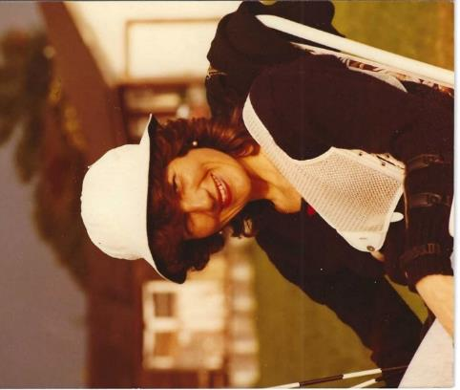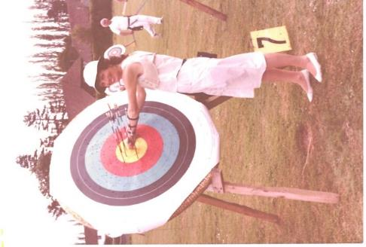
Jane at an evening practice sessions Another six gold end, shot at 80 yards
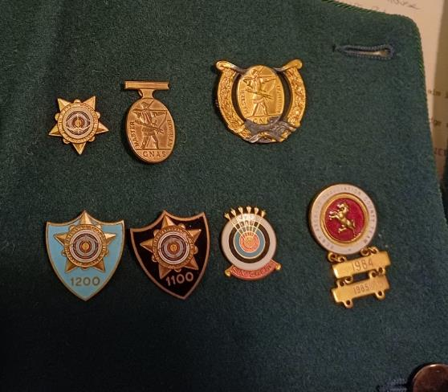
Shooting for the County of Kent, Jane
was awarded a green jacket.
Malcolm was able to show me the jacket,
complete with Jane’s badges: including
the Six-Gold End, Master Bowman, and
Grand Master Bowman. Bottom right is
a Kent Team badge with bars for 1984
and 1985. Bottom left are FITA 1100 and
1200 badge awarded for high scores in
FITA 1400 rounds. There is another
FITA 1100, not pictured (FITA, now WA)
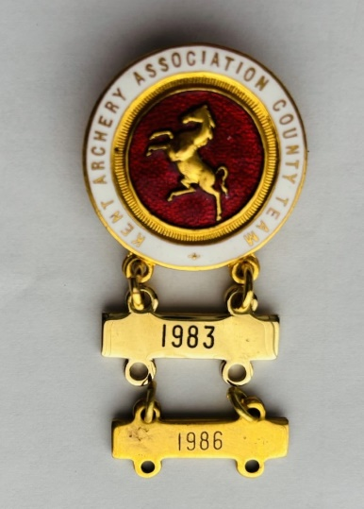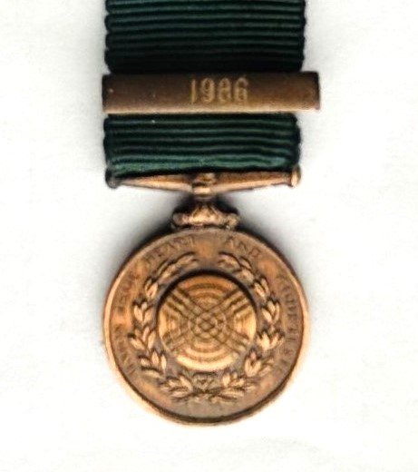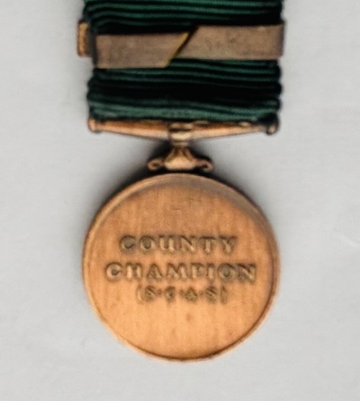
Left – Jane’ Kent team badge 1983 and 1986.
Right – Jane’s Southern Counties Archery Society, County Champion Medal, 1986
Below is an extract from the Bexley Arts Council “ARTS REVIEW”, Winter 1983/84
The Lamorbey Park Centre was dedicated to adult education in Bexley and offered a whole range of activities. This is Lamorbey Park Archers shooting on the lawns by the lake.
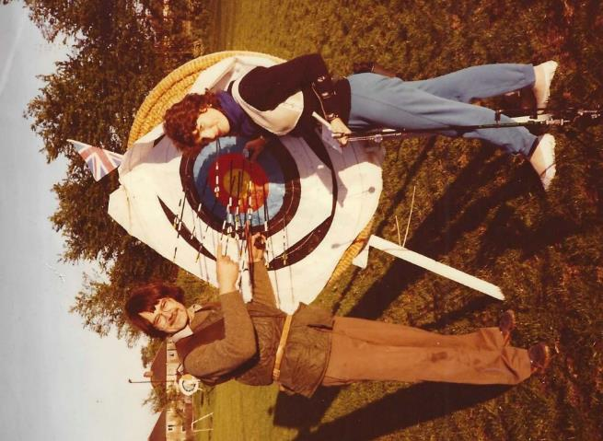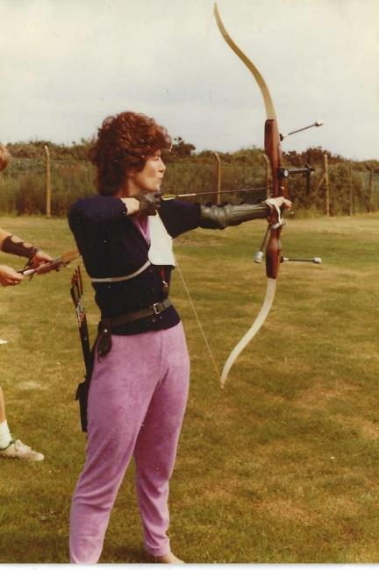
1980’s evening practice sessions for Malcolm and Jane
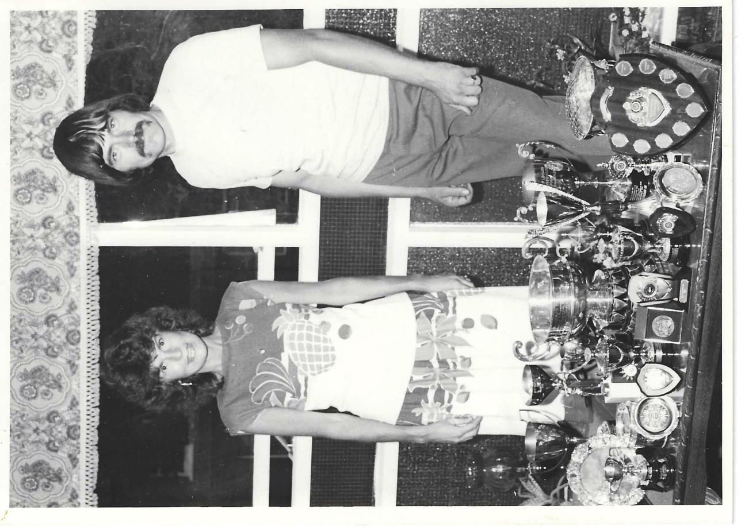
This is the original of the picture in the Arts Review article above, worth showing full size.

