Peter Boyd, a Notable LPA Archer from the 1980’s
Text from this Magazine – “Showing their class Peter Boyd (Left) of Lamorbey Park, and Richard Priestman of Nethermoss stand by their 80 yard 6 gold end which they shot while sharing the target at Shotton towards the end of the season. Peter and Richard were placed fourth and third respectively in “The Glade” Top 100 of FITA Star Shooters. A short while after this photo was taken Peter put in another 80 yard, 6 golds, this time all within the “10” ring.”
As mentioned elsewhere, Peter was the Southern Counties Recurve Champion four years in a row. He was the GNAS Recurve champion for 3 years, and the Kent Recurve champion 6 times.
He also made the British Squad prior to the Seoul Olympics in 1988, but didn’t compete, he did however shoot for Great Britain in the US (Cincinnati & Phoenix), Israel, Belgium and Switzerland, which he loved.
Back in the 1980’s they shot together at Lamorbey Park Archers, now Peter Boyd (left) and Malcolm Brent have been reunited on the Lamorbey Park Archers Range in 2026.
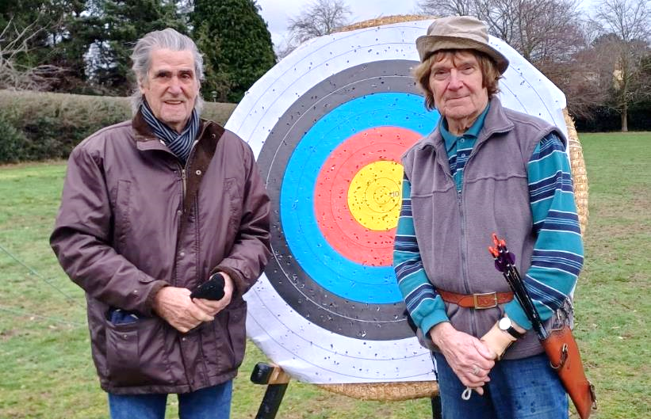
On a recent visit to our field Peter gave me an idea of the single-minded approach he had to his archery back in the 1980’s, recording details of every single arrow he shot in a note book. He earned the nick-name he was given – “Mister Unapproachable”, because he spoke to nobody during competitions, fearing it would break his concentration. In contrast to his archery he devoted a period of his life to road cycling, covering significant distances at significant speeds. Peter now enjoys collecting and cataloguing stamps, and is a volunteer with the Friends of Foots Cray Meadows.
Another picture from the Spring 1987 edition of The Glade magazine, showing Peter “flying the flag” for Lamorbey Park Archers in Canterbury, with another trophy.
